CS 499 Module One Assignment Template

Complete this template by replacing the bracketed text with the relevant information.

- Self-Introduction: Address all of the following questions to introduce yourself.

  - How long have you been in the Computer Science program?
I have been in the computer science program since May, 2024.

  - What have you learned while in the program? List three of the most important concepts or skills you have learned.
Throughout the program I have dived into the establishment of Databases, the creation of Mobile programs, and Agile product development.

  - Discuss the specific skills you aim to demonstrate through your enhancements to reach each of the course outcomes.
The skills that I aim to demonstrate through my enhancements will be the product creation stage, Database creation and integration and having an ease of use implemented to ensure that all functions are simple to understand for every end user.

  - How do the specific skills you will demonstrate align with your career plans related to your degree?
I hope to move into a system administration or engineering role as I progress through my career so the skills I had listed above will all be utilized as I continue to move towards my career plans.

  - How does this contribute to the specialization you are targeting for your career?
Ensuring that I stay focused on making quality products is essential when it comes to targeting my career. Making half-finished projects or having projects that are overly complex will not allow for the every day individual to get full utilization out of the tools presented.

- ePortfolio Set Up:

  - Submit a screen capture of your ePortfolio GitHub Pages home page that clearly shows your URL.
    - You already have a repository in GitHub where you uploaded projects in previous courses. Your ePortfolio will reside in GitHub but can link to work at other sites, such as Bitbucket.

  - Use the GitHub Pages link in the Resource section for directions on:
    - How to create your GitHub website and publish code to GitHub Pages
    - Issues, such as adding links to other sites

  - Paste a screenshot of your GitHub Pages home page with your URL clearly showing in the space below.

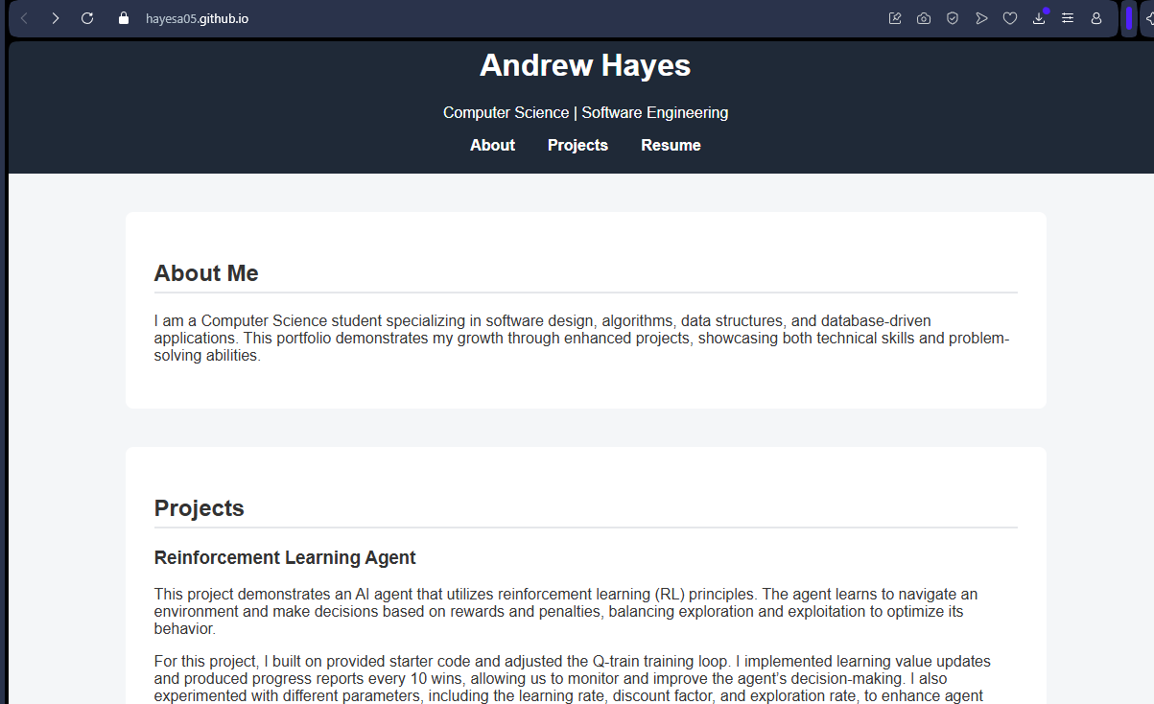
- Enhancement Plan:

  - Category One: Software Engineering and Design
    - Select an artifact that is aligned with the software engineering and design category and explain its origin. Submit a file containing the code for the artifact you choose with your enhancement plan.

The artifact that I have selected comes from CS-300. As of now it loads courses from a CSV file which is attached to the program and allows you to view requisites for each individual course. Right now it consists of a CSV which is 10 courses long.

Note: Your artifact may be work from the following courses:

- IT 145: Foundation in Application Development
- CS 250: Software Development Lifecycle
- CS 260: Data Structures and Algorithms
- IT 315: Object Oriented Analysis and Design
- CS 320: Software Testing, Automation, and Quality Assurance
- CS 330: Computational Graphics and Visualization
- CS 340: Advanced Programming Concepts
- CS 350: Emerging Systems Architectures and Technologies
- CS 360: Mobile Architecture and Programming
- IT 365: Operating Environments
- IT 380: Cybersecurity and Information Assurance
- CS 405: Secure Coding
- CS 410: Reverse Software engineering
- IT 340: Network and Telecommunication Management
- IT 380: Cybersecurity and Information Assurance

    - Describe a practical, well-illustrated plan for enhancement in alignment with the category, including a pseudocode or flowchart that illustrates the planned enhancement.

For the enhancement for planning when it comes to this software I am going to be working towards implementing a SQL database and expanding the structure of the code to ensure that it stays up to date and allows for you to sort for your category depending on your major while also having all course requisites listed. This will allow for an auto-populating database where any changes from courses will also reflect within the program itself.

For this category of enhancement, consider improving a piece of software, transferring a project into a different language, reverse engineering a piece of software for a different operating system, or expanding a project’s complexity. These are just recommendations. Consider being creative and proposing an alternative enhancement to your instructor.

Think about what additions to include to complete the enhancement criteria in this category. Since one example option is to port to a new language, that is the kind of scale that is expected. This does not mean you need to port to a new language but instead have an equivalent scale of enhancement. Underlying expectations of any enhancement include fixing errors, debugging, and cleaning up comments, but these are not enhancements themselves.

    - Explain how the planned enhancement will demonstrate specific skills and align with course outcomes.

      - Identify and describe the specific skills you will demonstrate that align with the course outcome.

The enchancement will demonstrate my ability to correctly and efficiently design a product with clear goals ensuring that each object will align to allow for fluidity throughout each portion of the application.

      - Select one or more of the course outcomes below that your enhancement will align with.

For the design of the product I think that the outcome that I will be most happy with will be to create a device which quickly and accurately returns each individual course catalogue.

Course Outcomes:

- Employ strategies for building collaborative environments that enable diverse audiences to support organizational decision-making in the field of computer science.
- Design, develop, and deliver professional-quality oral, written, and visual communications that are coherent, technically sound, and appropriately adapted to specific audiences and contexts.
- Design and evaluate computing solutions that solve a given problem using algorithmic principles and computer science practices and standards appropriate to its solution while managing the trade-offs involved in design choices.
- Demonstrate an ability to use well-founded and innovative techniques, skills, and tools in computing practices for the purpose of implementing computer solutions that deliver value and accomplish industry-specific goals.
- Develop a security mindset that anticipates adversarial exploits in software architecture and designs to expose potential vulnerabilities, mitigate design flaws, and ensure privacy and enhanced security of data and resources.

  - Category Two: Algorithms and Data Structures

- Select an artifact that is aligned with the algorithms and data structures category and explain its origin. Submit a file containing the code for the artifact you choose with your enhancement plan. You may choose work from the courses listed under Category One.

The data structure for my CS-300 project is currently operating of VS code and a CSV with the written out requirements along with the processes. Having a complex environment where you can have courses learn each sub requirement will be vital to visually see each career path needed.

- Describe a practical, well-illustrated plan for enhancement in alignment with the category, including a pseudocode or flowchart that illustrates the planned enhancement.

Ensuring that the product is able to cross-reference each course is a necessity to ensure that each course is up to date with the latest information possible. Having the product aligned with a database will allow for this to crosscheck with the wepages course catalogs which will allow for each individual process to update as needed.

For this category of enhancement, consider improving the efficiency of a project or expanding the complexity of the use of data structures and algorithms for your artifact. These are just recommendations. Consider being creative and proposing an alternative enhancement to your instructor. Note: You only need to choose one type of enhancement per category.

Think about what additions to include to complete the enhancement criteria in this category. Since one example option is to port to a new language, that is the kind of scale that is expected. Perhaps you might increase the efficiency and time complexity of an algorithm in an application and detail the logic of the increased time complexity. Remember, you do not need to port to a new language but instead have an equivalent scale of enhancement. Underlying expectations of any enhancement include fixing errors, debugging, and cleaning up comments, but these are not enhancements themselves.

- Explain how the planned enhancement will demonstrate specific skills and align with course outcomes.

  - Identify and describe the specific skills you will demonstrate to align with the course outcome.

The specific skills demonstrated with this will be clean code design with purpose along with ensuring that it is labeled correctly and future proof for any potential additions throughout the code.

  - Select one or more of the course outcomes listed under Category One that your enhancement will align with.

For the outcome I would like a SQL database to have dynamic sorting along with retrieval functions for efficiency purposes.

  - Category Three: Databases

    - Select an artifact that is aligned with the databases category and explain its origin. Submit a file containing the code for the artifact you choose with your enhancement plan. You may choose work from the courses listed under Category One.

I once again will be utilizing the same project from CS-300. The reason this project fits the category is because it currently sorts through a CSV where the is no real data repository set up for the product. This limits scalability and maintainability.

    - Describe a practical, well-illustrated plan for enhancement in alignment with the category, including a pseudocode or flowchart that illustrates the planned enhancement.

Attaching a continuous running SQL database will allow for on the go updates along with pulling with the most up to date repositories. Having up to date information is vital to success within the educational realm due to the fact that if a requisite changes then you will have to ensure that you satisfy the individual course requirements.

PSEUDOCODE:

Initialize database connection
IF courses table does not exist:
Create courses table with fields (CourseID, Title, Department, Prerequisites)
Import CSV into database (one-time)
For user query:
Execute SQL SELECT with ORDER BY and JOIN for prerequisites
Display results in application

For this category of enhancement, consider adding more advanced concepts of MySQL, incorporating data mining, creating a MongoDB interface with HTML/JavaScript, or building a full stack with a different programming language for your artifact. These are just recommendations; consider being creative and proposing an alternative enhancement to your instructor. Note: You only need to choose one type of enhancement per category.

Think about what additions to include to complete the enhancement criteria in this category. Since one example option is to port to a new language, that is the kind of scale that is expected. Perhaps you might increase the efficiency and time complexity of an algorithm in an application and detail the logic of the increased time complexity. Remember, you do not need to port to a new language but instead have an equivalent scale of enhancement. Underlying expectations of any enhancement include fixing errors, debugging, and cleaning up comments, but these are not enhancements themselves.
    - Explain how the planned enhancement will demonstrate specific skills and align with course outcomes.

      - Identify and describe the specific skills you will demonstrate that align with the course outcome.

This will showcase my database design and normalization while also showcasing my capability to create SQL query and integration application logic. Finally, having dynamic data handling for current and accurate information.

      - Select one or more of the course outcomes listed under Category One that your enhancement will align with.

The course outcome will be to evaluate solutions utilizing algorithmic pinciples, implement solutions that deliver value with tools and techniques and ensuring that there is data integrity along with controlling access for the SQL database.

- ePortfolio Overall Skill Set

  - Accurately describe the skill set to be illustrated by the ePortfolio overall.
    - Skills and outcomes planned to be illustrated in the code review

I will ensure that I demonstrate software engineering princils giving a modular design and enhancement planning. Additionally, giving algorithms for efficiency and scalabiulity. Finally, A database design for integration and management.

    - Skills and outcomes planned to be illustrated in the narratives

Having clear communication for decisions and enhancements, Articulating contributions along with problem solving processes, and Alligning the enhancements for the course and professional goals.

    - Skills and outcomes planned to be illustrated in the professional self-assessment

Reflection on learning and growth through not only this class but the entire degree program.
Transferable skills for future career goals such as database development and ensuring that I am able to effectively translate my ideas into function.
Presing a portfolio that allows for me to demonstrate my full range of technical competencies and career readiness.

